- Do not edit/delete any heading or section with red text.
- Type /paste you answers in relevant sections (below Final Answer (in all questions , Approach (wherever required ) and Charts & tables (wherever required)) of the solution
- Link to submission guidelines
- Please note that submission not following the guidelines will not be accepted

OBJECTIVE QUESTIONS

Question 1: What is the total no. of attributes present in the data?

Solution:

Final Answer (if any):
16 Attributes

Approach (if any):
<Methodology, logic, formulas, or steps used to arrive at the answer>

Charts & Tables (if any):
- Table / Chart Name:
<Name of the table or chart used>
- Description:
<What the table or chart represents>

Question 2: Which columns have inconsistent or missing values, and what is the count of such values?

Solution:

Final Answer (if any):
There are no missing or inconsistent values in the data. Although, Severity and Priority columns consist data with incorrect spellings. Incorrect spellings with count mentioned as below-
- Severity Col - Unclasified instead of Unclassified, Count – 356
- Severity Col - Mayor instead of Major, Count - 4836
- Priority Col - Unassiged instead of Unassigned, Count - 29410

Approach (if any):
Used Find & Replace approach change incorrect with correct spellings. Mentioned incorrect values in Find what: section & correct values in Replace with: section.

Charts & Tables (if any):
Find and Replace approach – This is one of the example of above incorrect values.
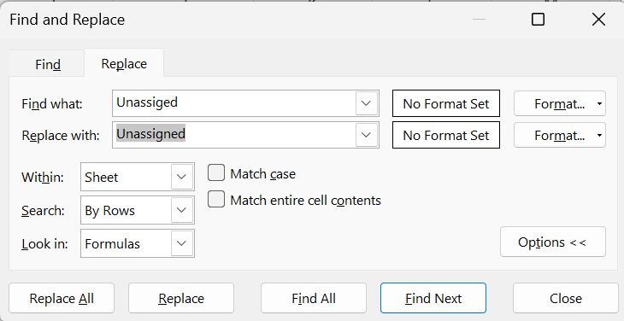

Question 3: What is the average daily ticket volume over time?

Solution:

Final Answer (if any):
The average daily ticket volume over time is 54.

Approach (if any):
Average monthly ticket count is 1625 (calculated using =ROUND(97498/60,0), which was divided by 30(days in a month) to get the count of daily ticket count.

Formula:
=ROUND(1625/30,0)

Charts & Tables (if any):
- Table / Chart Name:
<Name of the table or chart used>
- Description:
<What the table or chart represents>

Question 4: What is the distribution of ticket categories (e.g., Login Access, System, Software)?

Solution:

Final Answer (if any):
Distribution of Ticket Categories mentioned below-
- Hardware – 9733
- Login Access – 29193
- Software – 19570
- System – 39002

Approach (if any):
Used Pivot Table to find out the distribution of no. of tickets per category by placing
Rows – Request Category
Values – Count of ID Ticket

Charts & Tables (if any):
Pivot Table -
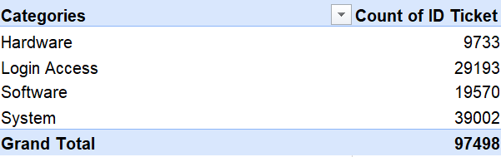

3-D Stacked Column to show distribution amongst the categories-
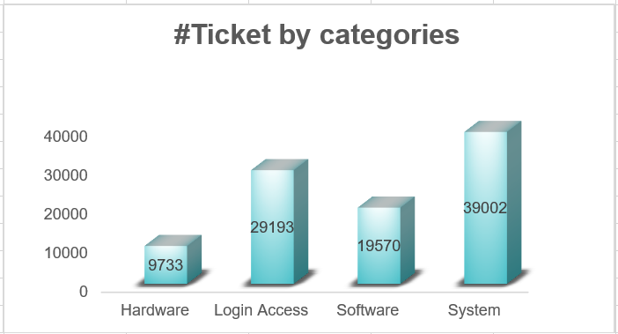

Question 5: How many tickets has each agent handled?

Solution:

Final Answer (if any):
There are 50 Agents and total no. of tickets handled by each agent has been calculated using Pivot Table.

Approach (if any):
Used Pivot Table approach to find out the count of ticket handled by each agent by placing –

Rows – Agent ID
Values – Count of ID Ticket

Charts & Tables (if any):
Pivot Table –
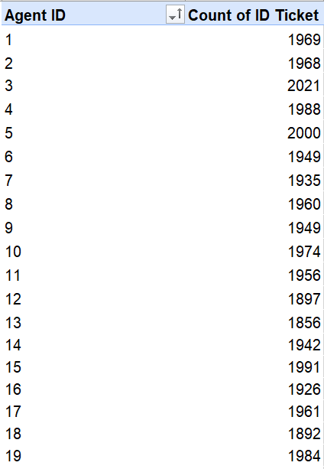
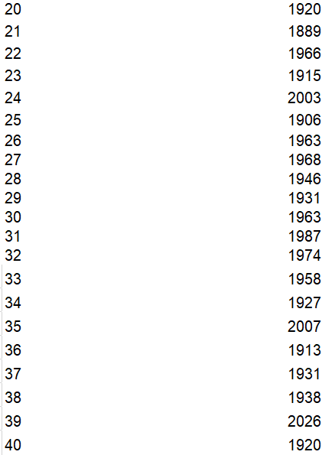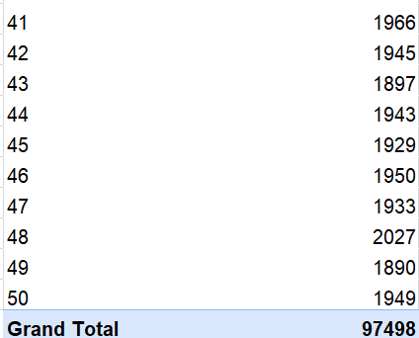

Question 6: How can you extract the domain from the email addresses in the IT Agents sheet?

Solution:

Final Answer (if any):
Used FIND to identify @ after which domain name starts, MID to extract everything after it and LEN to return all characters after @. Created a separate column for Domain Name in IT Agents sheet.

Approach (if any):
Formula: =MID(C2,FIND("@",C2)+1,LEN(C2)-FIND("@",C2)-4)

Charts & Tables (if any):
- Table / Chart Name:
<Name of the table or chart used>
- Description:
<What the table or chart represents>

Question 7: How can you find the full name of an agent given their Agent ID?

Solution:

Final Answer (if any):
Used VLOOKUP formula to fetch Agent Name for given Agent ID.

Approach (if any):
Formula: =VLOOKUP(D2,'IT Agents'!$A$1:$F$51,2,FALSE)
- VLOOKUP – to search data vertically
- D2- is the lookup value (Agent ID)
- IT Agents!$A$1:$F$51 – IT Agent sheet is the table range where we will find the Agent ID & Agent Name.
- 2 – Agent Name col index number
- FALSE – Exact Match

Charts & Tables (if any):
- Table / Chart Name:
<Name of the table or chart used>
- Description:
<What the table or chart represents>

Question 8: What is the count of each issue type (e.g., IT Error, IT Request)?

Solution:

Final Answer (if any):
Count of each Issue type is mentioned as below-
- IT Error – 24278
- IT Request – 73220

Approach (if any):
Used Pivot Table approach to identify count of each Issue Type by placing –

Rows – Issue Type
Values – Count of ID Ticket

Charts & Tables (if any):
Pivot Table –
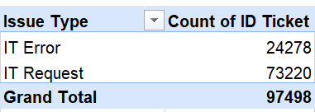

Question 9: What is the average resolution time for tickets?

Solution:

Final Answer (if any):
The average resolution time for tickets is 4.55 Days.

Approach (if any):
Used Pivot Table approach to calculate average resolution time for tickets by placing
Rows – Fecha (Date)
Values – Average of Resolution Time (Days)
Used ROUND function to reduce the decimal to 2, formula used –

=ROUND(GETPIVOTDATA("Resolution Time (Days)",$B$8),2)

Charts & Tables (if any):
Pivot Table –
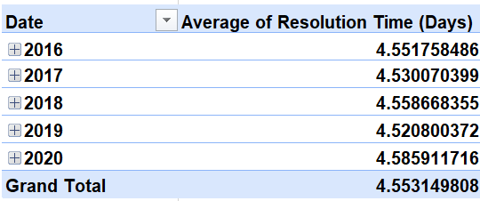

Question 10: How has the volume of tickets changed over time?

Solution:

Final Answer (if any):
The volume of IT tickets showed a strong and consistent upward trend from 2016 to 2020, indicating a continuous increase in IT support demand. The annual ticket count increased from 13,051 in 2016 to 14,915 in 2017, 18,954 in 2018, 21,490 in 2019, and reached 29,088 in 2020, representing an overall growth of approximately 123% over the five-year period. Monthly ticket volumes also increased steadily, rising from an average of 1,088 tickets per month in 2016 to 2,424 tickets per month in 2020, with the highest monthly volume of 2,609 tickets recorded in December 2020.

Reason:
The increase is most likely due to an increased reliance on IT services. Since 75.1% of tickets are IT Requests, with System and Login Access being the most common categories, the growth appears to be driven by increased user activity and routine IT support needs.

Conclusion:
The consistent year-over-year growth implies an increasing IT support workload, underlining the importance of scalable support resources and effective service management.

Approach (if any):
Used Pivot Table and Chart approach to analyse the volume of tickets over time by placing –
Rows – Fecha (Date)
Values – Count of ID Ticket
In addition, the count of tickets was investigated and compared to the Issue Type IT Error, IT Request (Refer Q8), and common request categories (Refer Q4) from previous findings to establish the reason for the increased number of tickets up to some extent.

Charts & Tables (if any):
Line Chart –

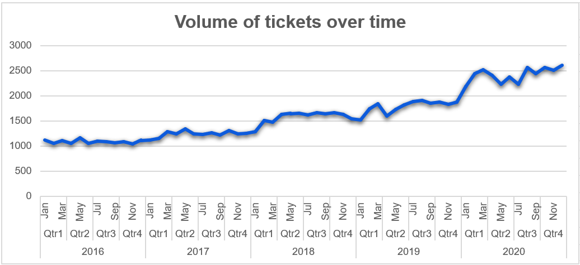

Pivot Table –
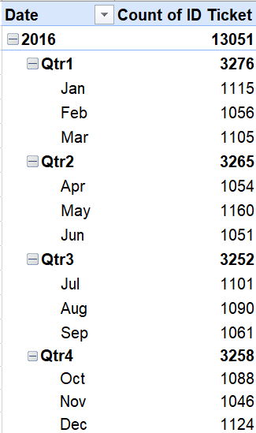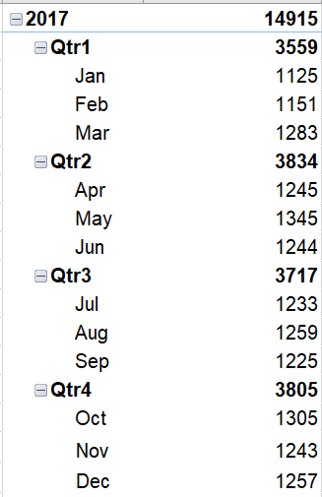

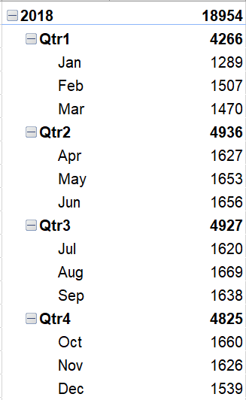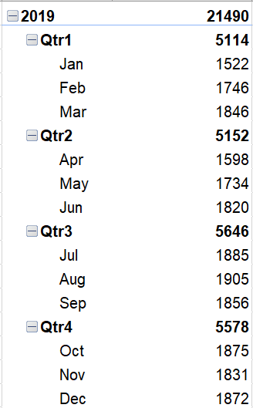

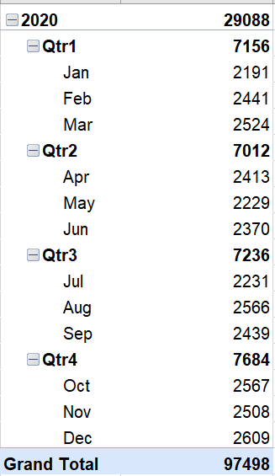

Question 11: What is the average age of the IT agents?

Solution:

Final Answer (if any):
Average age of IT Agents is 41 Years

Approach (if any):
Combined Year(D), Month(E), and Day(F) columns using DATE() to create the Date of Birth column,
Formula: =DATE(D2,E2,F2)
After which DATEDIF() was used to calculate each Agent's age and create a separate column,
Formula: =DATEDIF(H2,TODAY(),”Y”)
And AVERAGE() was used to determine the average age of all IT agents.
Formula: =AVERAGE(‘IT Agents’!I:I)

Charts & Tables (if any):
- Table / Chart Name:
<Name of the table or chart used>
- Description:
<What the table or chart represents>

Question 12: Is there a correlation between the severity of issues and the resolution time?

Solution:

Final Answer (if any):
No clear linear correlation exists between issue severity and resolution time. Although Normal severity (Score 2) tickets have the highest average resolution time (4.66 days), Urgent (Score 4) tickets are resolved the fastest (2.00 days), indicating that high-severity issues are prioritized for quicker resolution rather than taking longer to resolve.

Approach (if any):
Pivot Table & Chart approach was used to figure out the type of relation between severity issue and the average resolution time of a ticket.

Charts & Tables (if any):
Chart Name: Average Resolution Time by Severity
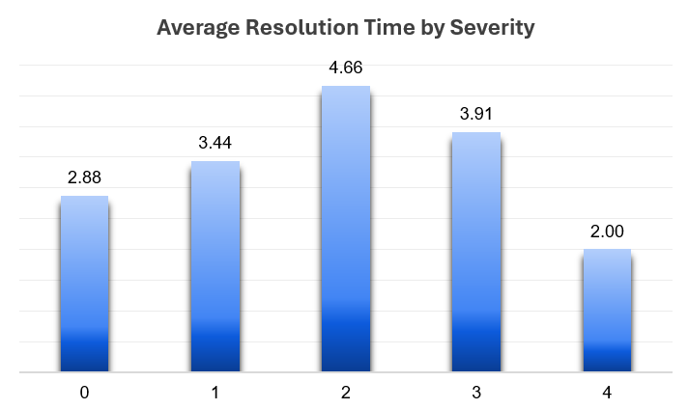

Pivot Table:
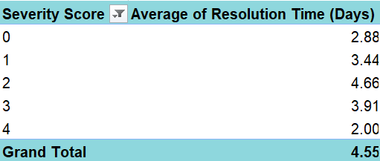
Description:
Displays the average number of days required to resolve tickets for each severity level (Unclassified, Minor, Normal, Major, and Urgent).

Question 13: How many categorical columns are there in the data? [Search about categorical and continuous data, and try to answer this question]

Solution:

Final Answer (if any):
There are total 7 Categorical columns present in the data including 3 Categorical (identifier) columns.

Categorical cols – Severity, Priority, Issue Type, Request Category
Categorical (Identifier) cols – ID Ticket, Agent ID, Employee ID
Approach (if any):
Categorical Data – Data that is expressed or represented in the form of categories or labels rather than measurable numeric values.

Categorical (Identifier) Data - Data that uniquely identifies each record and is not meaningful for mathematical operations or aggregation

Charts & Tables (if any):
- Table / Chart Name:
<Name of the table or chart used>
- Description:
<What the table or chart represents>

SUBJECTIVE QUESTIONS

Question 1: If there is an investment, should it be used to hire more IT agents, improve training programs, or upgrade ticket management software?

Analysis: Perform a cost-benefit analysis using ticket resolution and satisfaction metrics.

Solution:

Approach:
To identify the most suitable investment option, the analysis was based on ticket volume, average resolution time, customer satisfaction, ticket priority, request category, and agent performance. Since the dataset does not contain financial information such as hiring costs, software implementation costs, or training expenses, the recommendation is based on operational performance rather than monetary return.

Charts & Tables:
Chart Name: Ticket Volume by Request Category
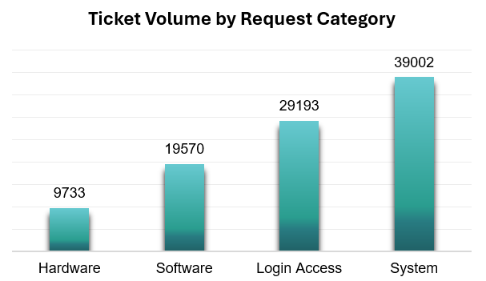

Pivot Table:
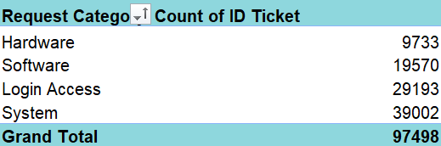

Description:
Shows the number of tickets received across Hardware, Software, Login Access, and System requests.

Chart Name: Average Resolution Time by Request Category
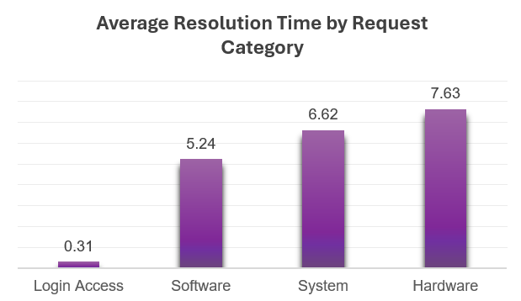

Pivot Table:
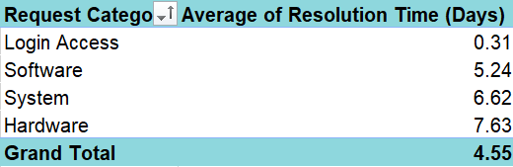

Description:
Compares the average number of days required to resolve tickets in each request category.

Chart Name: Ticket Distribution by Priority
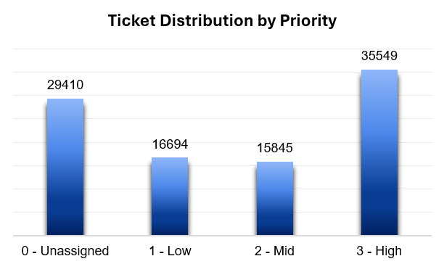

Pivot Table:
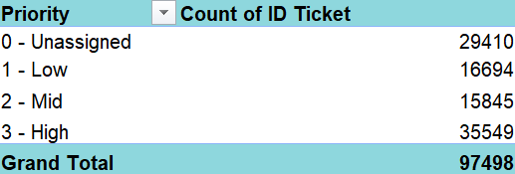

Description:
Shows the number of tickets across different priority levels.

Insights:
- Ticket volume has increased steadily over the years, but the average satisfaction score has remained stable at 4.10, indicating that the current team is handling the growing workload effectively.

- Hardware (7.63 days) and System (6.62 days) requests have the highest average resolution times, suggesting that delays are concentrated in specific request categories rather than across the entire support process.

- Around 30% of tickets (29,410) remain Unassigned, highlighting an opportunity to improve ticket routing and workload distribution through better processes or automation.

Recommendations:
- Prioritize investment in training programs. Strengthening technical and troubleshooting skills, particularly for Hardware and System requests, is likely to reduce resolution time while maintaining high customer satisfaction.

- Upgrade the ticket management software as the next step. Better ticket routing, automation, and workload balancing can help reduce the large number of unassigned tickets and improve operational efficiency.

- Consider hiring additional IT agents only if ticket demand continues to increase after process and training improvements. Based on the current analysis, improving team capability and workflow is likely to provide greater value than expanding the workforce immediately.

Question 2: Which agents need additional training based on their performance metrics?

Analysis: Identify agents with the lowest satisfaction ratings and longest resolution times.

Solution:

Approach:
To identify agents who may require additional training, two key performance metrics were analysed:
Average Satisfaction Rating – Lower ratings indicate lower customer satisfaction.
Average Resolution Time (Days) – Higher resolution times indicate slower ticket resolution.

The 10 lowest-rated agents were compared with the 10 slowest agents to identify common agents who consistently underperform across both metrics.

Charts & Tables:
Chart Name: Lowest Rated Agents by Average Satisfaction Rating
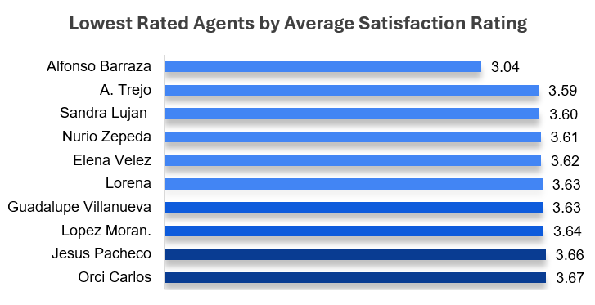
Pivot Table:
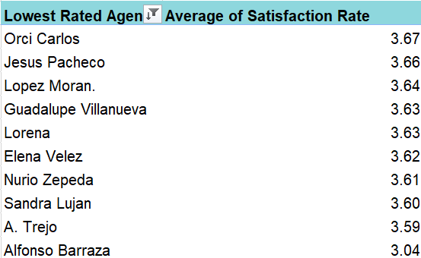

Description:
Displays the 10 agents with the lowest average customer satisfaction ratings.

Chart Name: Slowest Agents by Average Resolution Time
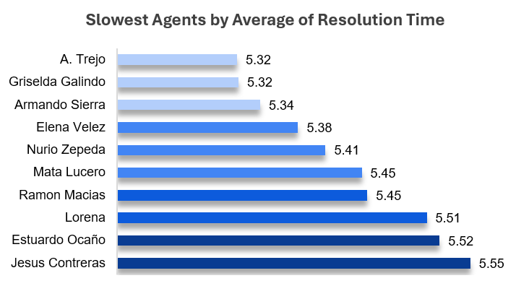

Pivot Table:
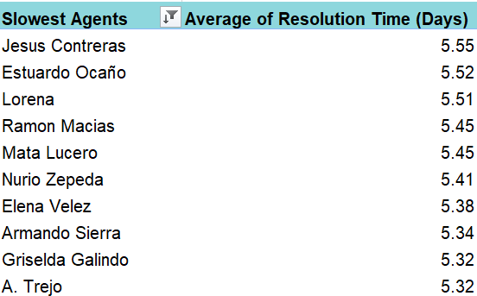

Description:
Displays the 10 agents with the highest average resolution time, indicating slower ticket resolution.

Insights:
- The analysis compared the 10 lowest-rated agents by Average Satisfaction Rating with the 10 slowest agents by Average Resolution Time to identify agents consistently underperforming across both metrics.
- Four agents were common in both lists:

A. Trejo – Satisfaction Rating: 3.59 | Average Resolution Time: 5.32 days
Nurio Zepeda – Satisfaction Rating: 3.61 | Average Resolution Time: 5.41 days
Elena Velez – Satisfaction Rating: 3.62 | Average Resolution Time: 5.38 days
Lorena - Satisfaction Rating: 3.63 | Average Resolution Time: 5.51 days

- These agents have comparatively lower customer satisfaction ratings while also taking longer to resolve tickets. This indicates a need for improvement in both technical efficiency and customer handling, making them the highest priority candidates for additional training.

Recommendations:
- Provide technical and process efficiency training to A. Trejo, Nurio Zepeda, Lorena and Elena Velez to improve troubleshooting skills and reduce resolution time.
- Conduct customer service and communication training to help improve customer interactions and satisfaction ratings.
- Pair these agents with top-performing agents for mentoring and knowledge sharing.
- Monitor their performance regularly after training to evaluate improvements in both resolution time and customer satisfaction.

Question 3: Do certain categories of requests have longer resolution times?

Analysis: Analyze the resolution times by request category.

Solution:

Approach:
To investigate whether some request categories take longer to resolve than others, the Average Resolution Time (in days) for each Request Category was calculated using a Pivot Table (Dashboard-Service Performance). A clustered column chart was then generated to graphically compare the average resolution time across all categories.
The analysis compared four request categories:

- Login Access
- Software
- System
- Hardware

The category with the greatest average resolution time denotes the type of request that takes more work, complexity, or troubleshooting before it being resolved.

Charts & Tables:
Chart Name: Average Resolution Time (Days) by Request Category
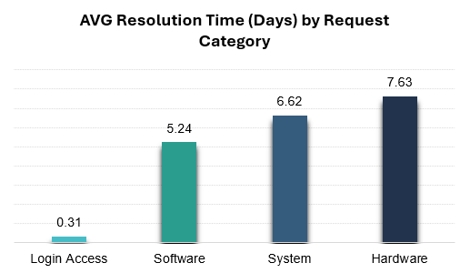

Description:
This Clustered Column chart visually compares the average resolution time in days for each request category, making it easy to identify which categories are resolved quickly and which requires more time.

Pivot Table:
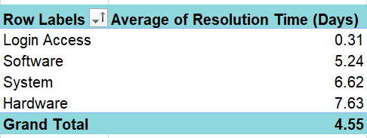

Insights:
- Hardware requests have the highest average resolution time (7.63 days), indicating they are the most time-consuming to resolve.
- System requests take an average of 6.62 days, making them the second most time-consuming category.
- Software requests have a moderate average resolution time of 5.24 days, which is slightly longer than the overall average.
- Login Access requests are answered fast, with an average resolution time of 0.31 days, indicating that these issues are typically basic and follow regular procedures.
- Overall Average Resolution Time for all request categories is 4.55 days.

The overall difference in average resolution time indicates that the complexity across the categories significantly impacts resolution time.

Recommendations:
- Focus on High-Impact Areas: Since Hardware and System requests take longer to resolve, provide specialized training, assign experienced engineers, and strengthen documentation for these categories.

- Adopt Best Practices: Login Access requests are resolved very quickly. Identify the efficient workflows or automation used here and implement similar practices for other suitable request categories.

- Improve Self-Service Resources: Expand the knowledge base and troubleshooting guides to help reduce dependency on support teams for common issues.

Question 4: How effective are the current software tools in managing IT tickets?

Analysis: Evaluate performance metrics before and after the implementation of new tools.

Solution:

Approach:
The dataset does not provide any information about when new software tools were introduced or performance before and after implementation. Therefore, it is not possible to directly compare the effectiveness of old and new tools.

Instead, the current IT ticket management system was evaluated using available metrics such as ticket priority, severity, average resolution time, and overall ticket handling performance.

Charts & Tables:
Chart Name: Priority Vs Volume of Ticket
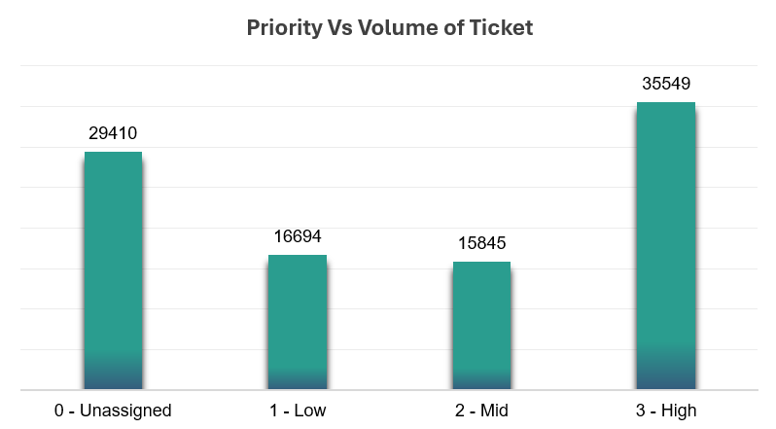

Pivot Table:
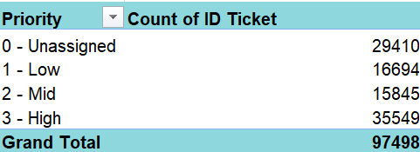

Description:
Shows the number of tickets across different priority levels, helping evaluate whether tickets are being assigned and managed effectively.

Chart Name: Average Resolution Time (Days) by Severity
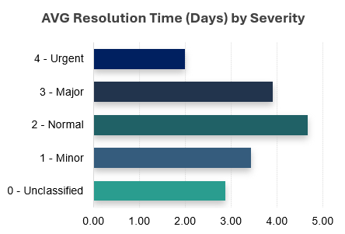

Pivot Table:
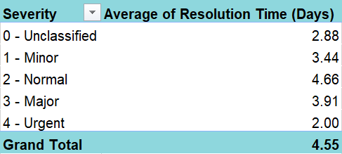

Description:
Shows the average resolution time for each severity level, indicating how efficiently tickets of different criticality are being resolved.

Insights:
- 35,549 High Priority tickets show that the system is capable of identifying and handling important issues.
- Around 29,410 tickets are marked as Unassigned, indicating that a large number of requests are entering the system without a defined priority.
- Urgent tickets are resolved in 2.00 days, whereas Normal severity tickets take the longest time (4.66 days). This suggests that critical issues are handled quickly, while routine issues remain pending for longer.

Overall, the current software performs well in managing critical tickets but shows scope for improvement in ticket prioritization and workflow management.

Recommendations:
- Ensure every ticket is assigned a priority before it enters the resolution process.

- Review the workflow for Normal severity tickets to identify the reasons behind their longer resolution time.

- Automate ticket classification and priority assignment to reduce manual errors and improve consistency.

- Regularly monitor priority distribution and resolution time to identify bottlenecks and improve overall service efficiency.

Question 5: How has the performance of the IT support team changed over time (e.g., monthly or quarterly)?

Analysis: Trend analysis using time series charts.

Solution:

Approach:
To understand how the IT support team's performance changed over time, a quarterly trend analysis was performed for the period 2016–2020. Three key performance metrics were analysed:

Quarterly Ticket Volume to understand changes in workload.
Quarterly Average Resolution Time (Days) to measure operational efficiency.
Quarterly Average Satisfaction Rating to evaluate customer experience.

Analysing these three metrics together provides a complete picture of the team's performance over time.

Charts & Tables:
Chart Name: Average Resolution Time (Days) by Severity

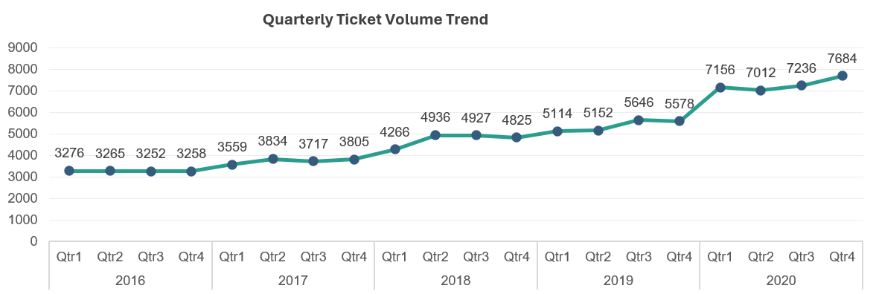

Description:
Displays the total number of IT tickets received in each quarter from 2016 to 2020.

Chart Name: Quarterly Average Resolution Time Trend
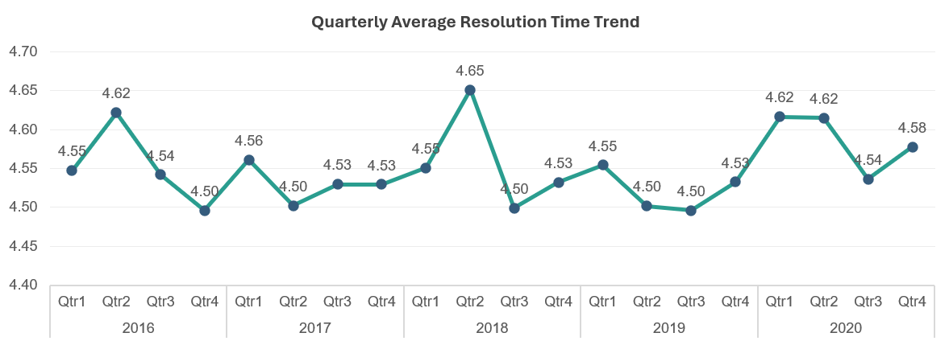

Description:
Shows the quarterly average number of days taken to resolve IT tickets.

Chart Name: Quarterly Average Satisfaction Rate Trend
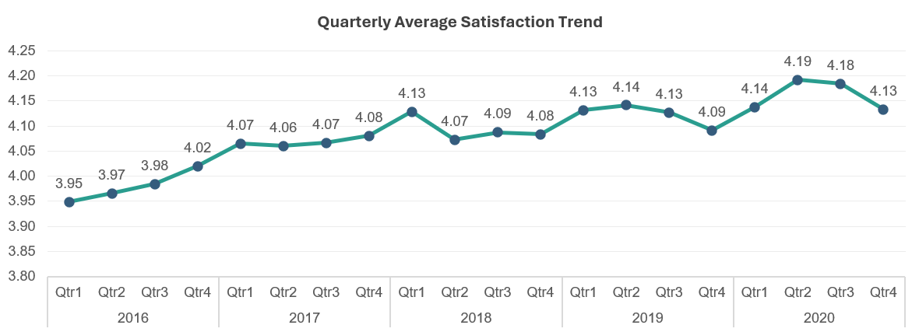

Description:
Shows the quarterly average customer satisfaction rating throughout the analysis period.
Insights:
- The number of tickets increased consistently over the five years. Ticket volume almost doubled from 3,276 tickets in Q1 2016 to 7,684 tickets in Q4 2020, showing that the IT support team handled a much higher workload by the end of 2020.

- Even with the increase in ticket volume, the average resolution time remained fairly stable, ranging between 4.49 and 4.65 days. There were small fluctuations across quarters, but no major increase or decrease in resolution time.

- Customer satisfaction improved over the years. The average satisfaction score increased from 3.95 in Q1 2016 to 4.19 in Q2 2020 and remained above 4.10 during most of 2019 and 2020.

- The findings show that although the workload kept increasing, the team was able to maintain a similar resolution time while improving customer satisfaction. This reflects a positive overall performance trend.

Recommendations:
- As ticket volume is increasing every year, the IT team should plan resources accordingly to avoid delays in the future.

- The current ticket handling process should be reviewed regularly to keep the average resolution time close to 4.5 days.

- The practices that improved customer satisfaction from 3.95 to 4.19 should be identified and continued.

- Quarterly review of ticket volume, resolution time, and satisfaction rating should be carried out to monitor the team's performance and identify any issues early.

Question 6: If we invest more on tech (Hardware, software, etc), do you think it will improve the ticket resolution times and employee satisfaction?

Analysis: Use historical data to project potential improvements.

Solution:

Approach:
The dataset does not contain information about technology investments or performance before and after any hardware or software upgrades. Therefore, the impact of investment cannot be measured directly.
To answer this question, the current performance was analysed using three metrics:
Ticket Volume by Request Category
Average Resolution Time by Request Category
Average Satisfaction Rating by Request Category

These metrics help identify where technology investments are most likely to improve IT support performance.

Charts & Tables:
Chart Name: Ticket Volume by Request Category
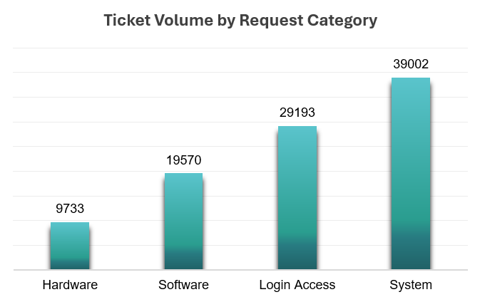

Pivot Table:
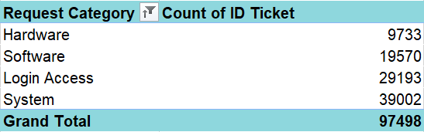

Description:
Shows the total number of tickets received under each request category.

Chart Name: Average Resolution Time by Request Category
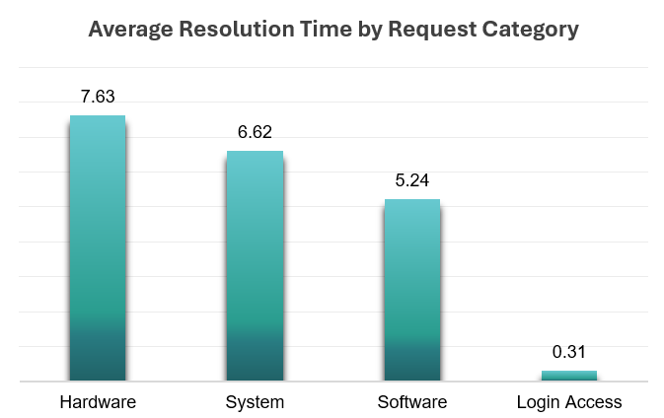
Pivot Table:
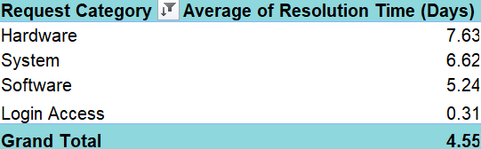

Description:
Shows the average number of days required to resolve tickets in each request category.

Chart Name: Average Satisfaction Rating by Request Category
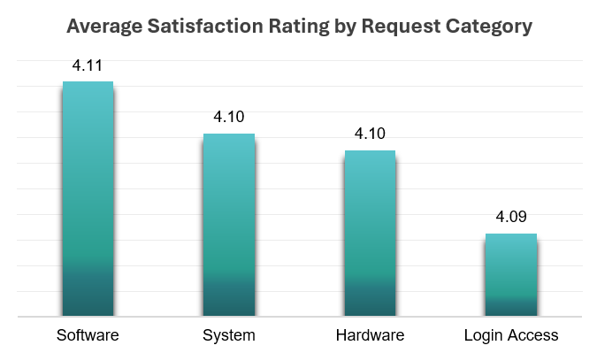

Pivot Table:
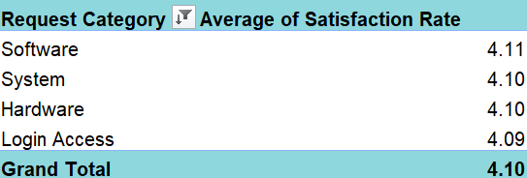

Description:
Shows the average customer satisfaction rating for each request category.

Insights:
- System generates the highest number of tickets (39,002), followed by Login Access (29,193), Software (19,570) and Hardware (9,733). This shows that System and Login Access requests contribute most to the IT team's workload.

- Although Hardware has the lowest ticket volume, it takes the longest time to resolve, with an average resolution time of 7.63 days. System (6.62 days) and Software (5.24 days) also require several days to resolve, while Login Access requests are completed much faster, averaging only 0.31 days.

- The average satisfaction rating remains almost the same across all request categories, ranging between 4.09 and 4.11. This suggests that users are generally satisfied with the support they receive, even though some request types take much longer to resolve.

- Based on the current data, investing in better technology, automation, and support tools is likely to reduce resolution time, especially for Hardware, System, and Software requests. Faster resolution would also help maintain or further improve employee satisfaction.

Recommendations:
- Invest in Hardware support tools such as asset management systems, spare part tracking, and remote diagnostic solutions to reduce the long resolution time for Hardware tickets.
- Upgrade System and Software support by improving monitoring tools, troubleshooting utilities, and the knowledge base so that recurring issues can be resolved more quickly.
- Expand automation for Login Access requests. Since these requests are already resolved quickly, additional self-service options like password reset and account unlock can further reduce manual effort and allow IT staff to focus on more complex issues.
- Monitor resolution time and satisfaction after implementing new technology to measure whether the investment is delivering the expected improvements and identify areas that need further attention.

Question 7: What are the key performance metrics for IT agents, and how can they be improved, do we need to fire any agents?

Analysis: Define and analyse metrics such as average handling time, satisfaction scores, and number of tickets resolved.

Solution:

Approach:
To evaluate the performance of IT agents, three key performance metrics were analysed:
- Number of Tickets Resolved – measures an agent's productivity by the number of tickets handled.
- Average Resolution Time (Days) – measures how efficiently an agent resolves tickets.
- Average Satisfaction Rating – measures the quality of support provided based on customer feedback.
These metrics were compared to identify top performers, agents who need improvement, and whether the current performance justifies terminating any employee.

Charts & Tables:
Chart Name: Top 10 Agents by Tickets Resolved
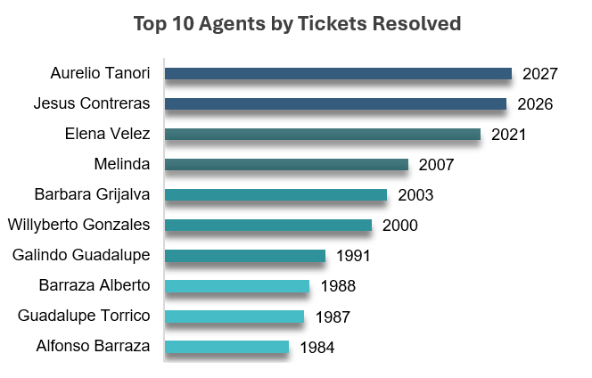

Pivot Table:
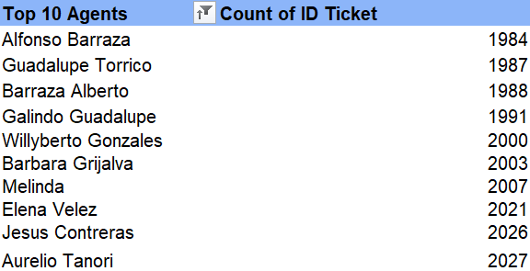

Description:
Shows the agents who resolved the highest number of IT tickets.

Chart Name: Top 10 Satisfaction Rated Agents
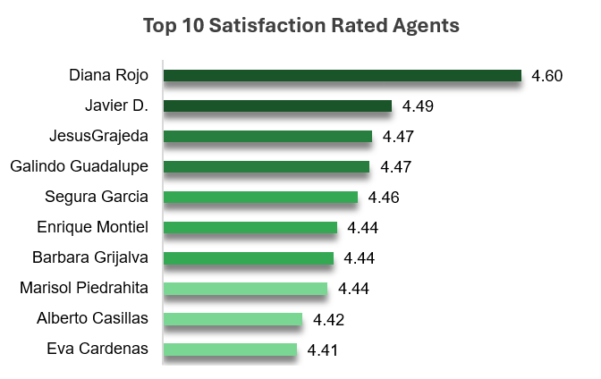
Pivot Table:
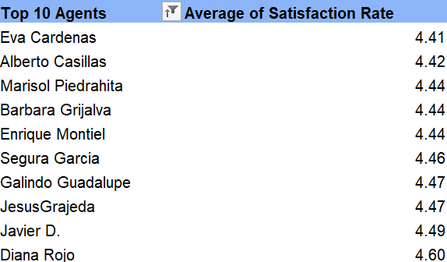

Description:
Shows the agents with the highest average customer satisfaction ratings.

Chart Name: Slowest Agents by Average Resolution Time
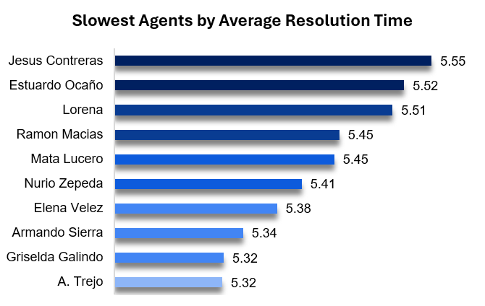

Pivot Table:
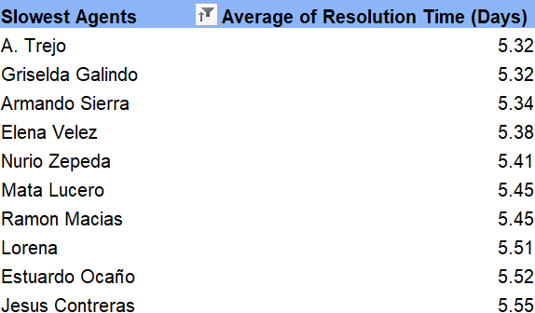

Description:
Shows the agents with the highest average ticket resolution time.

Chart Name: Lowest Rated Agents by Average Satisfaction Rating
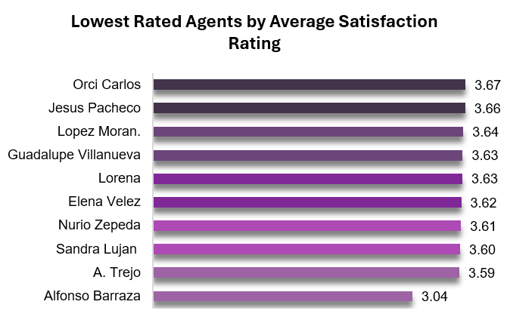

Pivot Table:
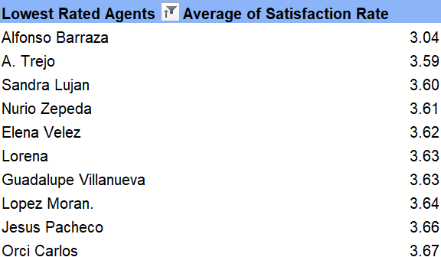

Description:
Shows the agents with the lowest average customer satisfaction ratings.

KPI’s:
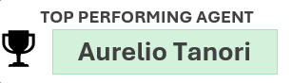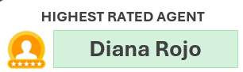

Description:
Shows the top performing agent and highest rated agent. Their techniques of performing work can be used as an example to boost weak agents performance.

Insights:
- Agent performance was evaluated using three key metrics: number of tickets resolved, average resolution time, and average satisfaction rating. Looking at these metrics together gives a better picture of overall performance than relying on just one measure.
- Aurelio Tanori resolved the highest number of tickets (2,027), making him the most productive agent in terms of workload handled. On the other hand, Diana Rojo received the highest average satisfaction rating (4.60), indicating strong customer service and user experience.
- Four agents appear in both the lowest satisfaction and highest resolution time lists:
A. Trejo – Satisfaction: 3.59, Resolution Time: 5.32 days
Elena Velez – Satisfaction: 3.62, Resolution Time: 5.38 days
Nurio Zepeda – Satisfaction: 3.61, Resolution Time: 5.41 days
Lorena – Satisfaction: 3.63, Resolution Time: 5.51 days

Since these agents are taking longer to resolve tickets while also receiving relatively lower customer ratings, they would benefit the most from targeted support and training.
Based on the available data, there is no evidence of consistently poor performance across the entire team. Most agents are performing well in at least one of the key performance metrics.

Recommendations:
- Provide targeted technical training to agents with higher resolution times, especially for handling Hardware and System-related issues.

- Arrange customer service and communication training for agents with lower satisfaction ratings to improve the overall user experience.

- Encourage knowledge sharing by having high-performing agents such as Aurelio Tanori and Diana Rojo share their troubleshooting methods and best practices with the team.

- Continue monitoring agent performance using a combination of ticket volume, resolution time, and satisfaction rating instead of evaluating performance using a single metric.

- There is no immediate need to fire any agent. The analysis suggests performance gaps can be addressed through training, mentoring, and regular performance reviews. Any decision regarding disciplinary action should only be considered if an agent continues to underperform even after receiving adequate support and improvement opportunities.

Question 8: How do employee demographics (e.g., department, seniority) impact satisfaction and ticket outcomes?

Analysis: Segment analysis using filters and pivot tables.

Solution:

Approach:
Since the dataset does not contain information such as department or seniority, Age Group was used as the employee demographic for this analysis. The performance of different age groups was compared using three key metrics:
  - Ticket Volume
  - Average Resolution Time
  - Average Satisfaction Rating
This helps identify whether age has any noticeable impact on workload, efficiency, and customer satisfaction.

Charts & Tables:
Chart Name: Ticket Volume by Age Group and Request Category
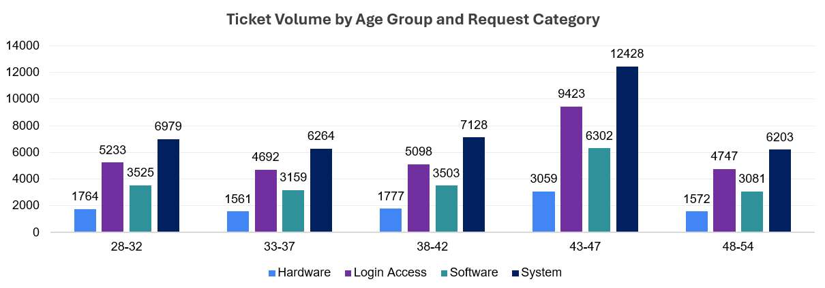

Pivot Table:
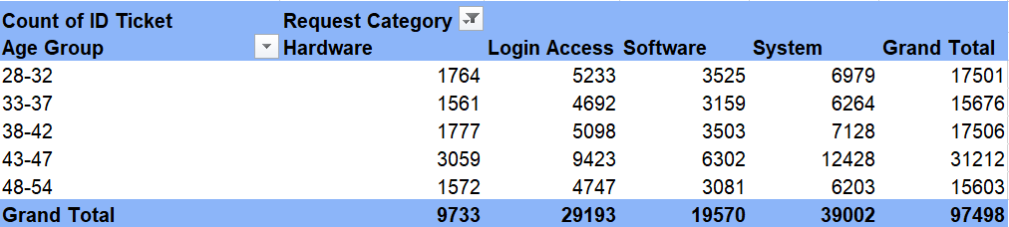

Description:
Shows the number of tickets handled by each age group across Hardware, Login Access, Software, and System requests.

Chart Name: Average Resolution Time by Age Group and Request Category
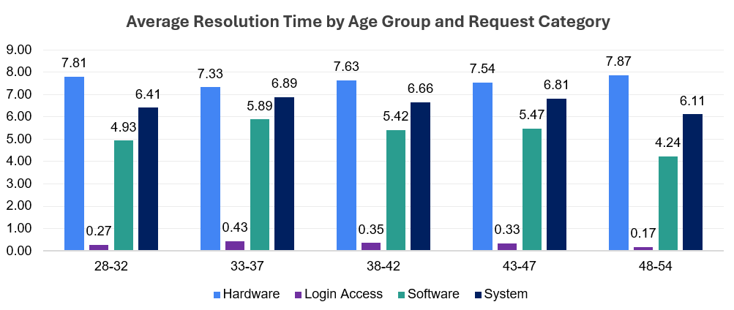

Pivot Table:
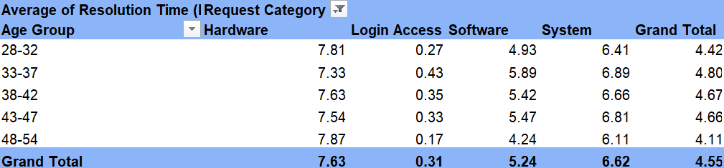

Description:
Shows the average number of days taken by each age group to resolve tickets in different request categories.

Chart Name: Average Satisfaction Rating by Age Group and Request Category
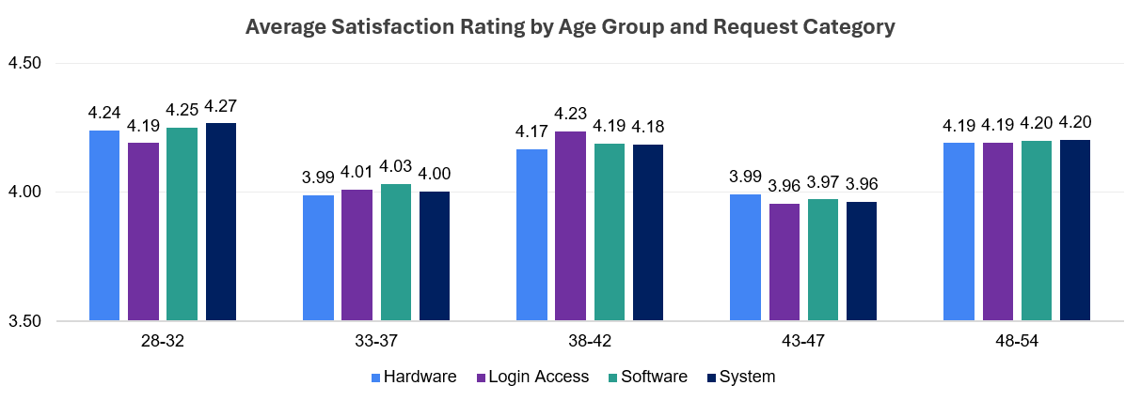

Pivot Table:
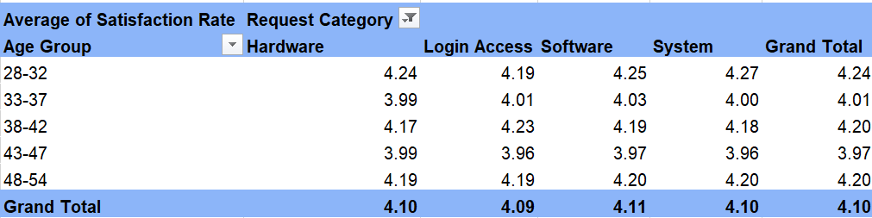

Description:
Compares the average customer satisfaction rating received by each age group across different request categories.

Insights:
- The 43–47 age group handled the highest number of tickets (31,012), while the 33–37 and 48–54 age groups handled comparatively fewer tickets. This suggests that the majority of the workload is currently managed by the 43–47 age group.

- Across all age groups, System requests have the highest ticket volume, whereas Hardware requests have the lowest. This shows that System-related issues are the most common, regardless of the agent's age.

- Hardware tickets take the longest to resolve for every age group, while Login Access tickets are resolved within a few hours. This indicates that the type of request has a bigger impact on resolution time than the age of the agent.

- The 48–54 age group resolves Software (4.24 days) and System (6.11 days) requests faster than the other age groups. This suggests that they are more efficient in handling these categories.

- The 33–37 age group has the highest resolution time for Software (5.89 days) and System (6.89 days) requests. With additional training and guidance, their performance in these areas can be improved.

- Customer satisfaction remains fairly consistent across all age groups, with ratings between 3.96 and 4.27. This indicates that although resolution times vary slightly, the quality of support provided by different age groups is generally similar.

Recommendations:
- Provide focused technical training to the 33–37 age group, especially for Software and System requests, to reduce their average resolution time.

- Encourage the 48–54 age group to share their experience and troubleshooting methods with other agents through mentoring or knowledge-sharing sessions.

- Since the 43–47 age group handles the highest number of tickets, review workload distribution regularly to avoid overloading this group and maintain consistent performance.

- Improve the Hardware support process by strengthening troubleshooting guides, spare-part availability, and technical documentation, as Hardware requests take the longest to resolve across all age groups.

- Continue maintaining the current level of customer service, as satisfaction ratings are consistently around 4.0 across all age groups. Future efforts should focus on improving resolution time while maintaining this level of customer satisfaction.

Question 9: Identify the trends for IT support operations based on ticket volumes and satisfaction, and mention the peak and stable times?

Analysis: Use pivot tables and charts to identify peak and off-peak hours.

Solution:

Approach:
<Reasoning, assumptions, and methodology used to solve the problem>

Charts & Tables:
Chart Name: Monthly Ticket Volume Trend
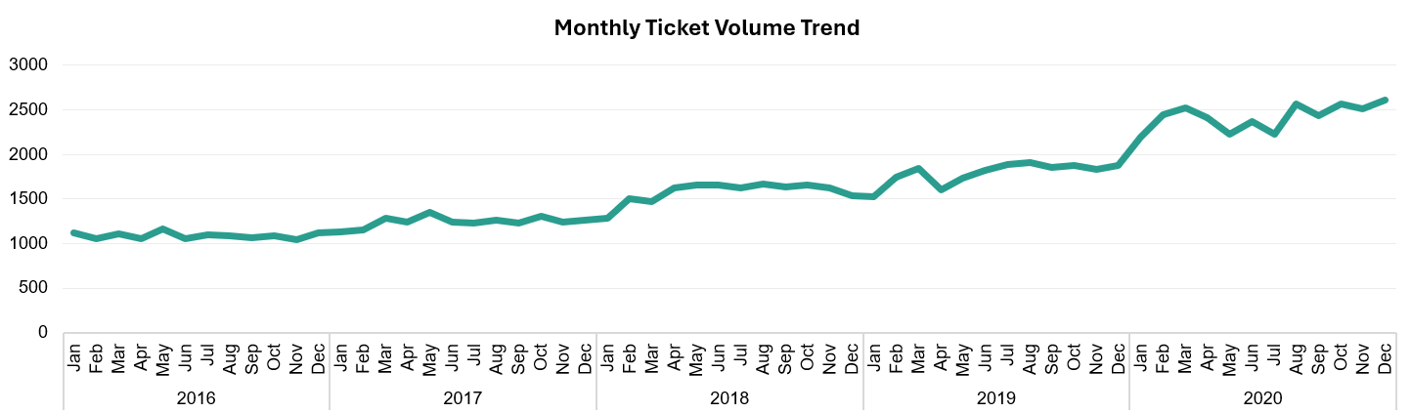

Description:
Shows the monthly number of IT tickets received between 2016 and 2020, helping identify changes in workload over time.
Chart Name: Monthly Ticket Volume Trend
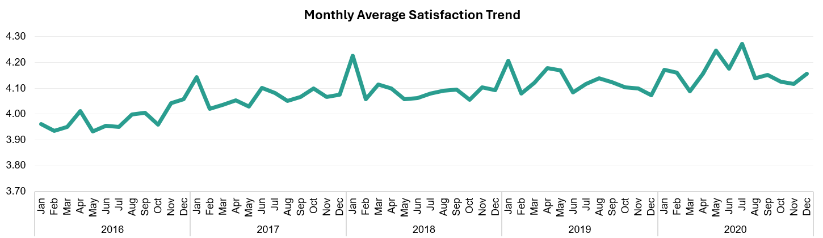

Description:
Shows the monthly average satisfaction rating during the same period to understand whether service quality changed as ticket volume increased.

Insights:
Ticket Volume Trend
- Ticket volume shows a clear upward trend over the five-year period. The monthly workload gradually increased from around 1,100 tickets in early 2016 to more than 2,600 tickets by the end of 2020, indicating a steady rise in IT support demand.

- 2020 was the busiest year, with ticket volume remaining consistently higher than previous years. The highest ticket volume was recorded in December 2020 (2,609 tickets).

- While there are small month-to-month fluctuations, the overall pattern shows a gradual increase rather than sudden spikes. This suggests that the growth in workload has been continuous over time.

Satisfaction Trend
- Customer satisfaction remained stable throughout the period, generally staying between 4.0 and 4.2, even as ticket volume increased.

- The highest satisfaction rating was 4.27 during July 2020, while the lowest ratings were observed during the early months of 2016.

- Even during the months with the highest ticket volumes, satisfaction remained above 4.1, showing that the support team was able to maintain service quality despite handling more requests.

Peak and Stable Periods
- Peak Period: The second half of 2020, particularly July to December, experienced the highest ticket volumes, with December 2020 recording the maximum number of tickets.
- Stable Period: Customer satisfaction remained consistently stable throughout the five years, with only minor month-to-month changes and no significant decline during high-workload periods.

Recommendations:
- Since ticket volume has increased steadily over the years, review staffing levels and resource planning regularly to ensure the support team can meet future demand.

- Plan additional support during periods of higher workload, especially when ticket volume starts rising in the later months of the year.

- Continue following the current service practices, as they have helped maintain customer satisfaction even with increasing ticket volumes.

- Identify common and repetitive issues and introduce automation or self-service options to reduce the number of incoming tickets.

- Monitor ticket volume and satisfaction trends every month so that potential workload increases can be identified early and resources can be planned accordingly.

Question 10: What metrics should be included in the final dashboard to provide a comprehensive view of call center performance and guide investment decisions?

Solution:

Approach:
The final dashboard was designed to provide management with a complete view of IT support operations. It combines overall business performance, service performance, agent performance, and business insights. Interactive slicers have been included to help management filter data and analyse performance from different perspectives before making investment decisions.

Charts & Tables:
Dashboard

Metrics Includes-

  - Total Tickets
  - Total IT Agents
  - Average Resolution Time
  - Average Satisfaction Rate
  - Average Monthly Tickets

Charts:

- Monthly Ticket Volume Trend
- Ticket Volume by Request Category
- Satisfaction Score over Time
- Ticket Volume by Priority
- Ticket Distribution by Satisfaction Score
- Ticket Distribution by Resolution Time (Days)
- Average Resolution Time (Days) by Request Category
- Ticket Distribution by Severity
- Satisfaction Score by Age Group

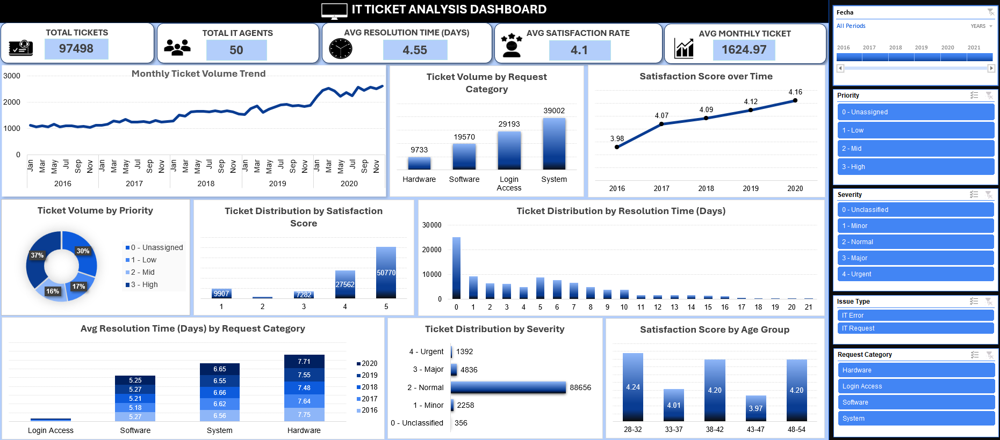

Description:
Provides an overall summary of IT support performance using key KPIs and operational charts.

Insights:
- The dashboard provides a complete picture of IT support performance by covering operational performance, service efficiency, agent productivity, and business trends in separate sections.

- The KPI cards allow management to quickly review the current performance, while the charts help identify trends, bottlenecks, and areas that require attention.

- The dashboard includes Year, Severity, Priority, Issue Type and Request Category slicers. These filters allow management to compare performance across different years and ticket types without creating separate reports.

- The combination of KPIs, trend charts, and agent performance metrics makes it easier to identify where additional investment is needed, such as improving Hardware and System support, reducing resolution time, or providing training to agents.

Recommendations:
- Use the dashboard as a regular performance monitoring tool to track changes in ticket volume, resolution time, customer satisfaction, and agent performance.
- During management discussions, use the Year, Priority, Severity, Issue Type and Request Category slicers to compare performance across different scenarios and support data-driven investment decisions.

- Continue monitoring the Monthly Ticket Volume and Satisfaction Score trends to identify periods of increased workload and plan resources accordingly.

- Use the dashboard to recognize top-performing agents, identify training needs, and balance workload across the team.

- Review the dashboard regularly to identify recurring issues, common request categories, and long-term trends that can guide future technology and process improvement investments.

